Git and GitHub Challenge.

1.Resolve Merge Conflicts.
- create a merge conflict intentionally. (two users editing the same line)

Creating and initializing a repository.
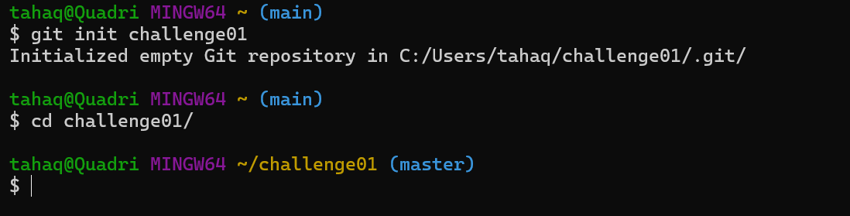
Here we have created a new file and added text in that.
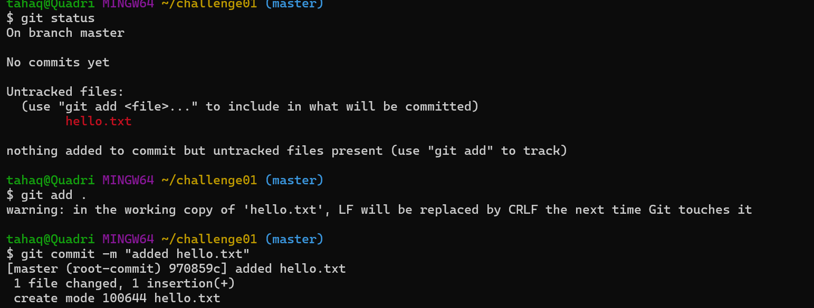

Now created a new branch and added content to the hello.txt and committed the changes from feature branch.

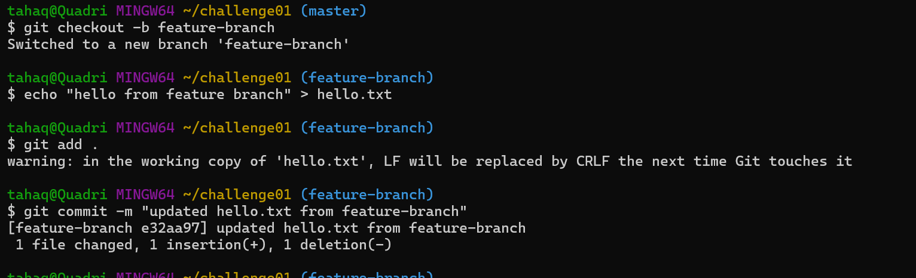

Now shifted to master branch and changed to the hello.txt same file.
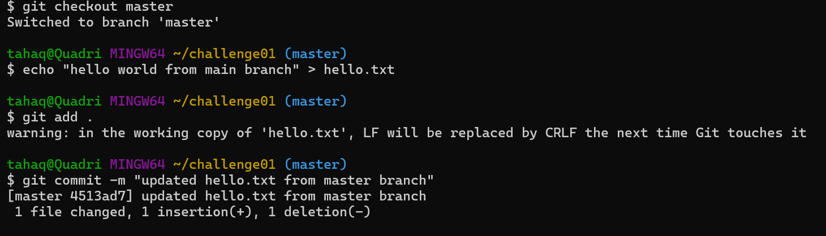
Now let’s merge from feature to main branch
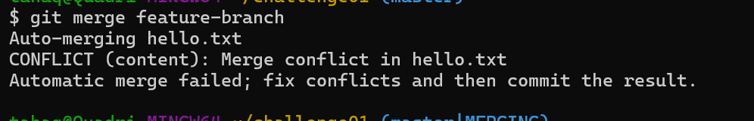
Here we have a conflict because in both branches we are editing the same line.
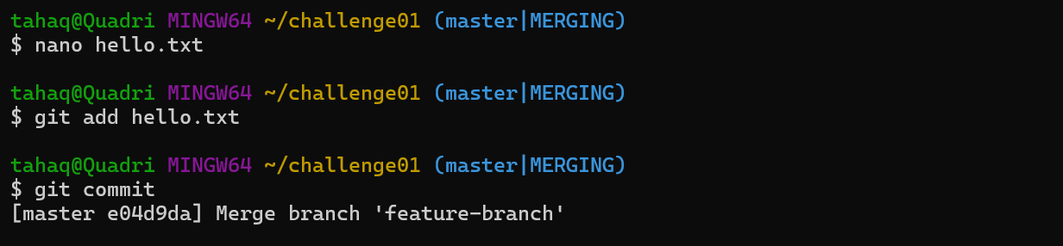

2.Resolve the conflicts and push the changes.
Now let’s resolve this conflict manually.
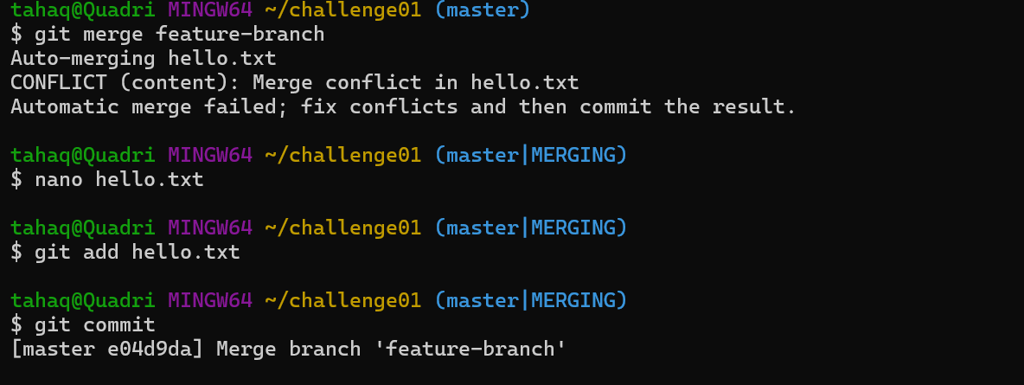
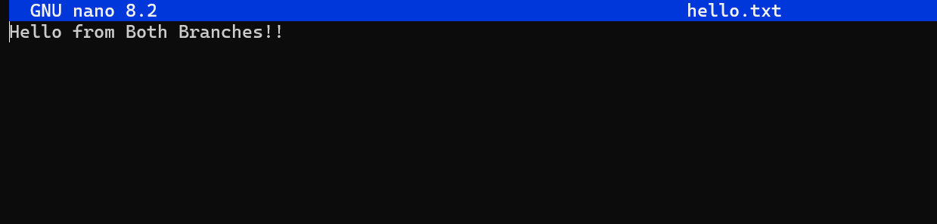
We have now pushed the changes to the remote repo as well.
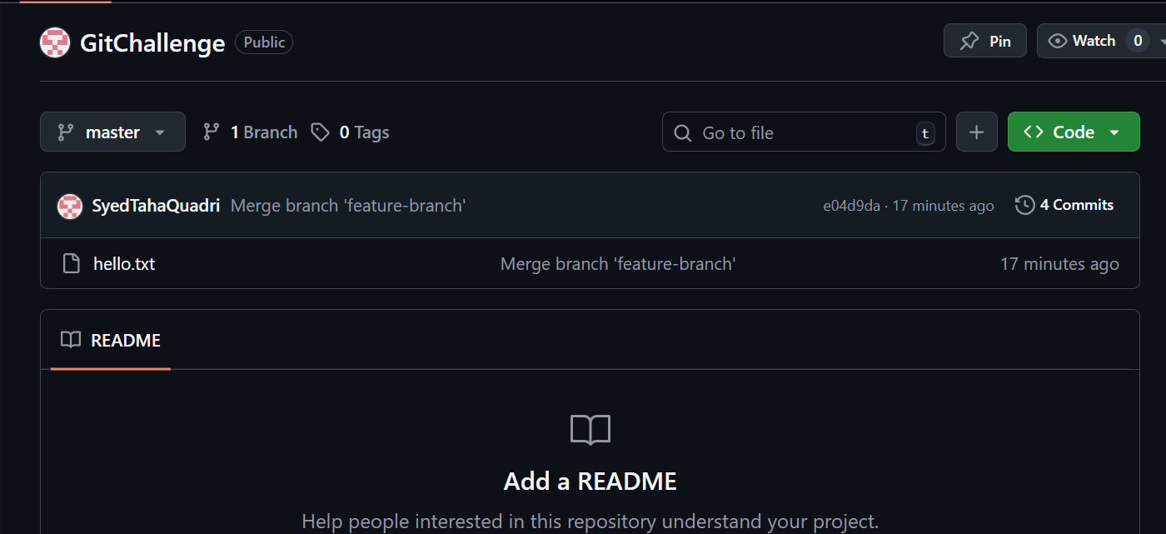

3. Recover a deleted branch:
Here I have created and switch to a branch named temp-branch
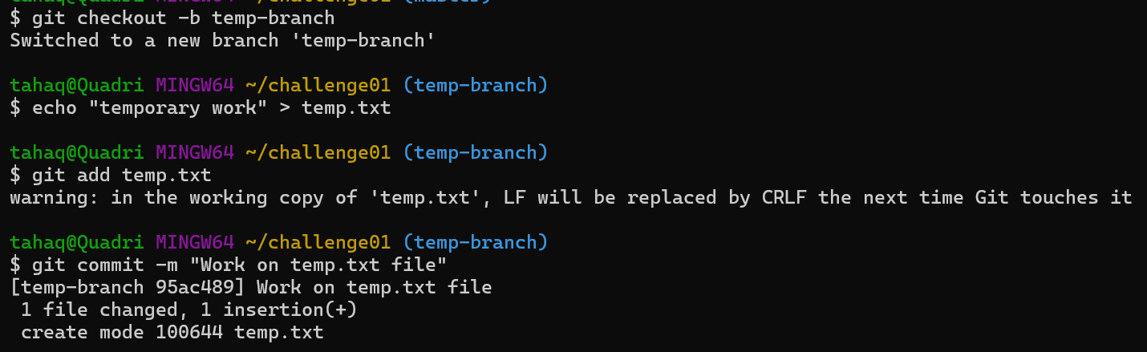
Now let’s switch to master and delete the newly created branch.
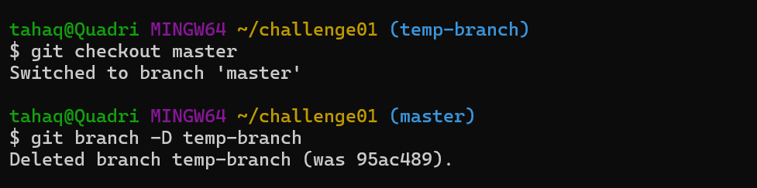
Now we need to recover the deleted branch we need to use git reflog for that.
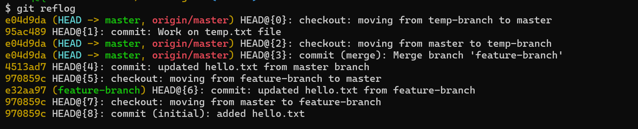
We need to identify the commit ID where we did our work.
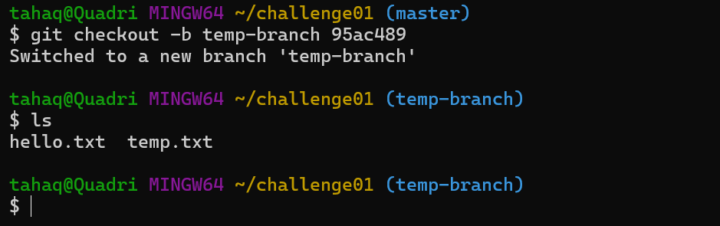

4. Undo a wrong Push.
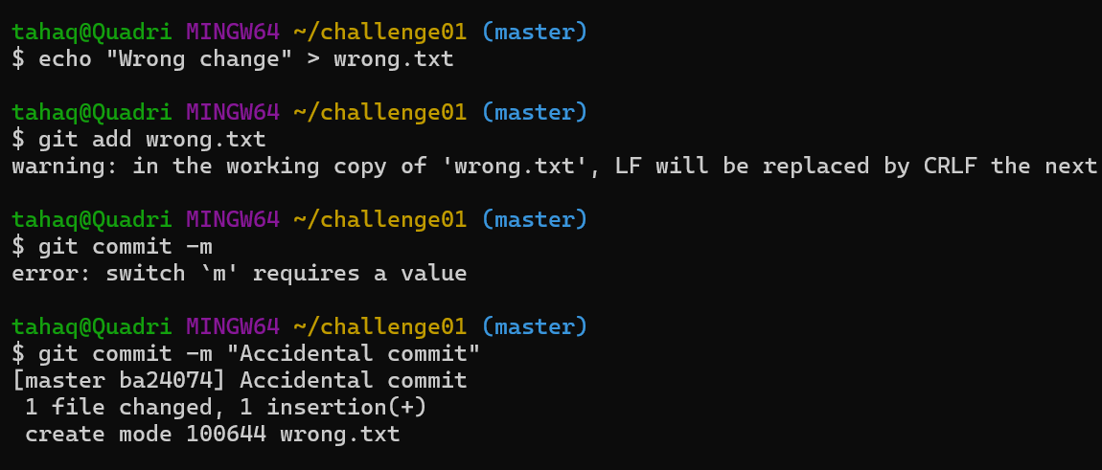
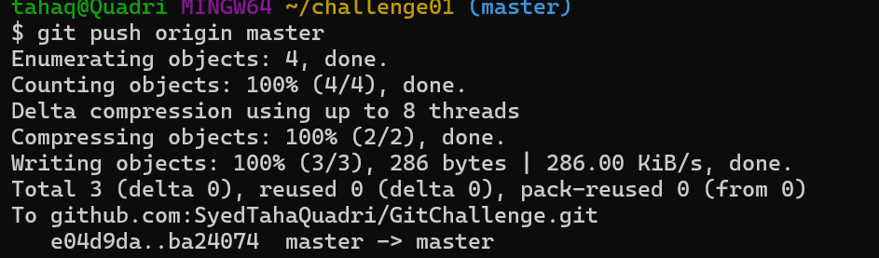
Here we pushed the wrong file to remote repo
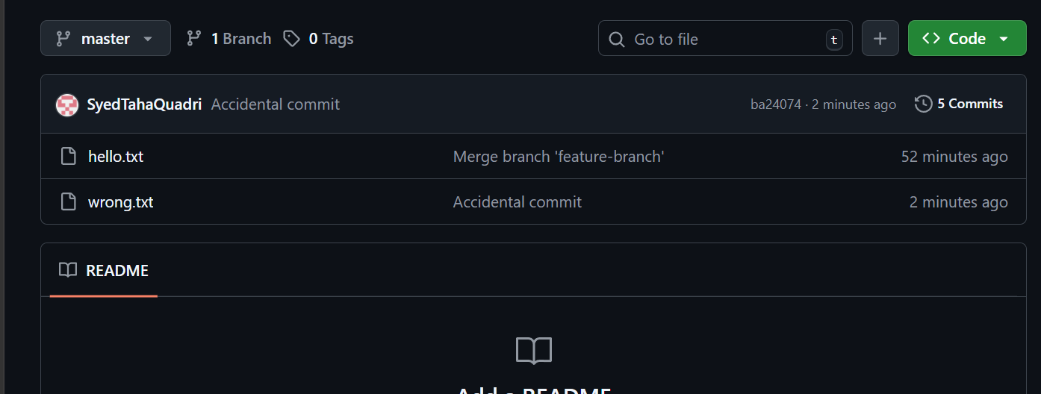

Because we did not want to push the wrong.txt file we need to undo the push now.
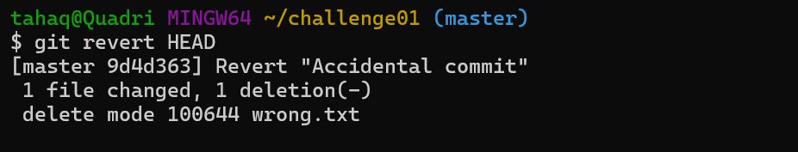
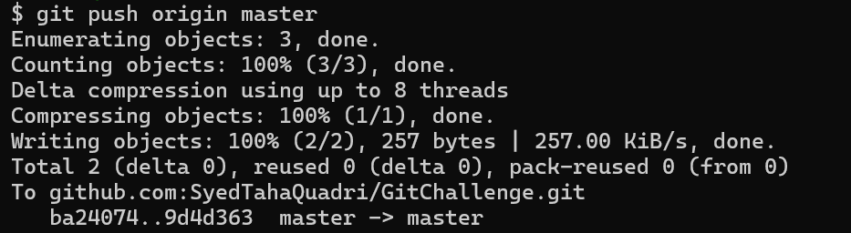
We have reverted the last commit and have pushed the changes to github as well.
Here the accidental commit is there but it is cancelled out.
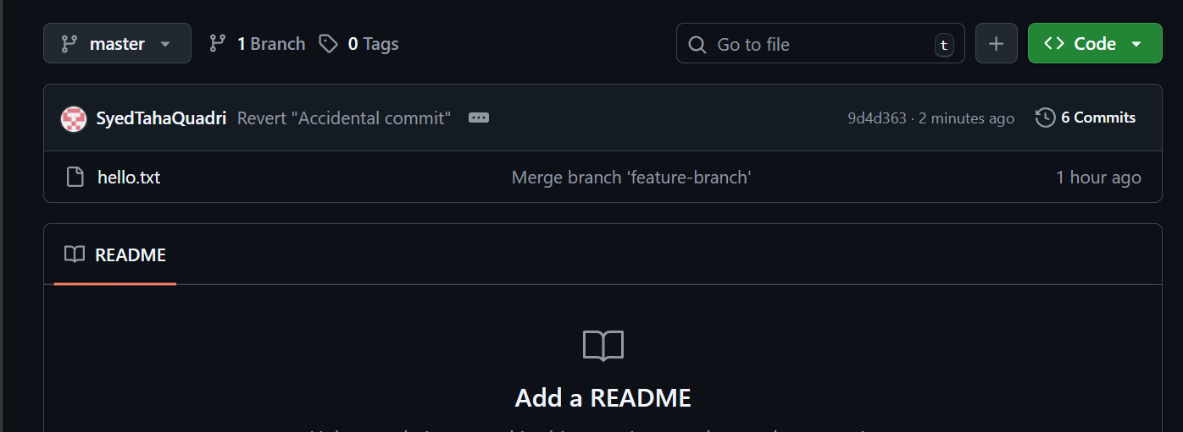

5.Amend a commit:
Make a commit, then add a missing file to it using git commit --amend.
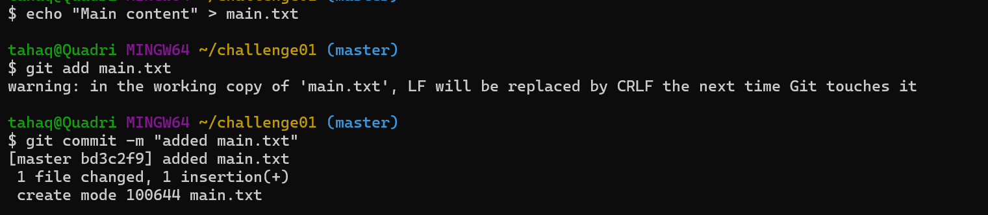
We have made a commit here and realized that we did not want to commit as they are some more changes to be done.
We have file named extra.txt that was supposed to be added in the same commit.
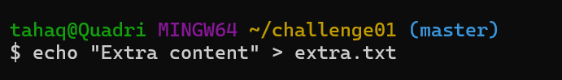
Let’s add this file and amend the old commit.
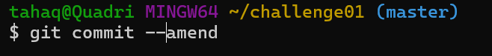
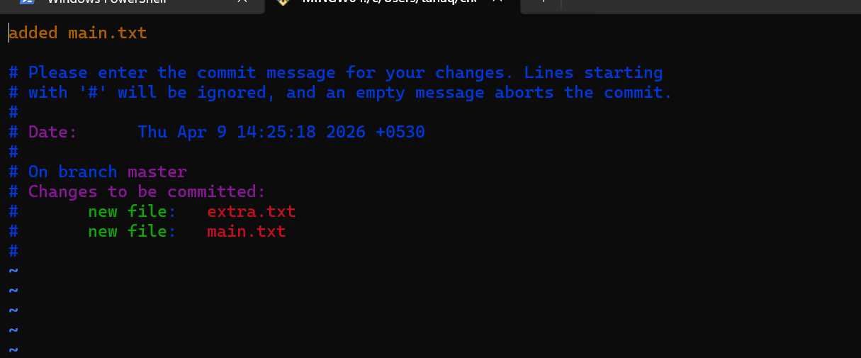
Here we will get this interface so we can change our commit message as well.
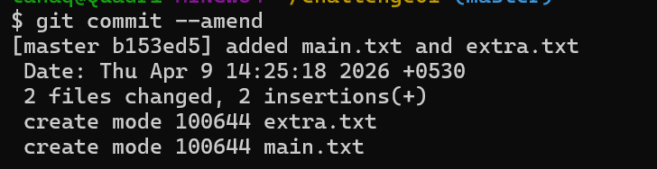
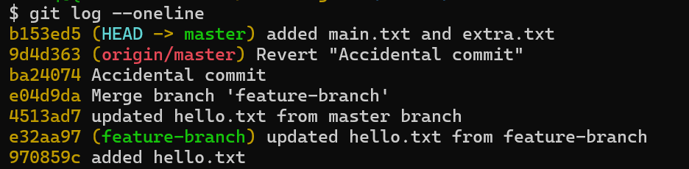
We have now added a missing file to the previous commit.

6.Cherry-pick a commit.
Take a specific commit from one branch and apply it to another branch.
Let’s create two branches and add changes to them.
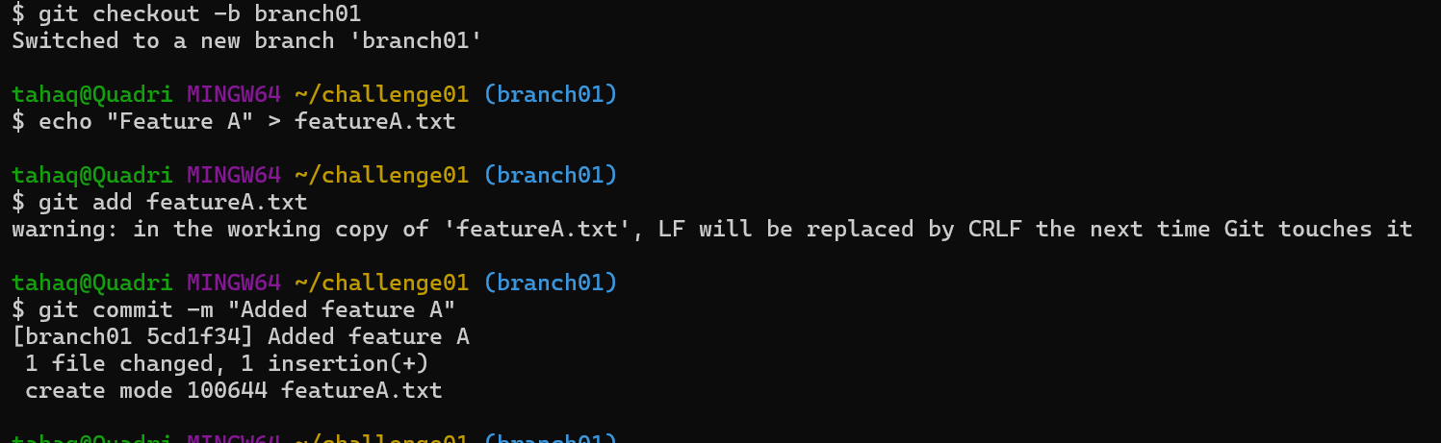
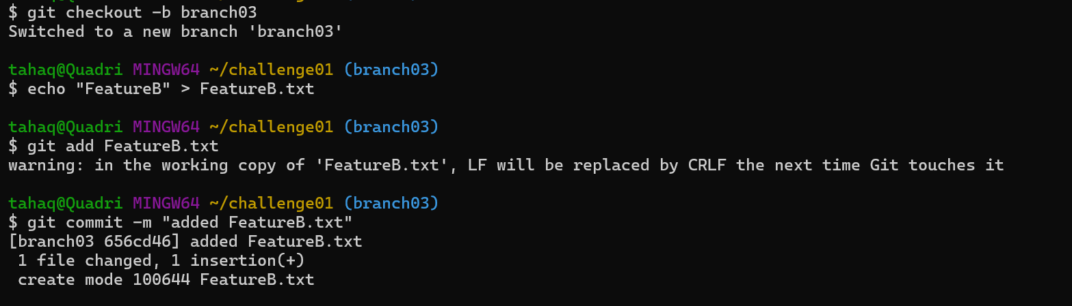

Now let’s suppose we want to have the FeatureB.txt from Branch03 in branch01
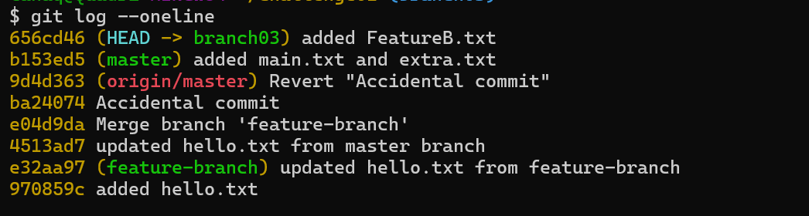
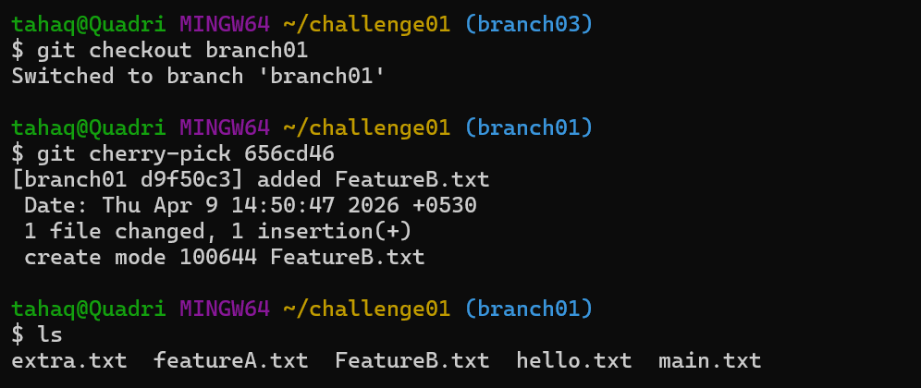
We have now cherry picked one commit from branch03 to branch01

7.Interactive Rebase:
Reorder and squash multiple commits into a single clean commit.
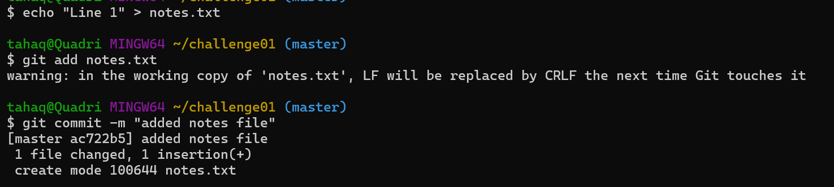
Here we have added changes to a file but we have 3 different commits for it.
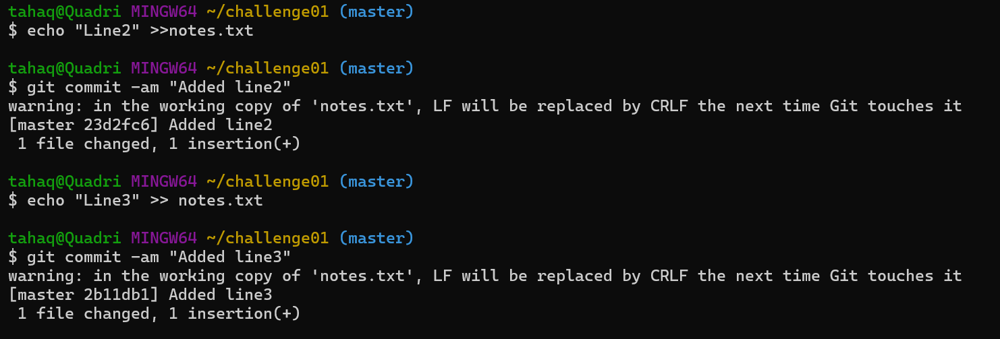
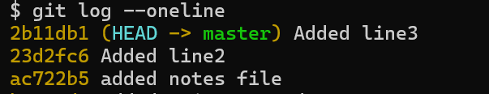
Now let’s squash the commits to make a clean history
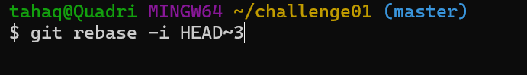
This means rebase the last three commits interactively.
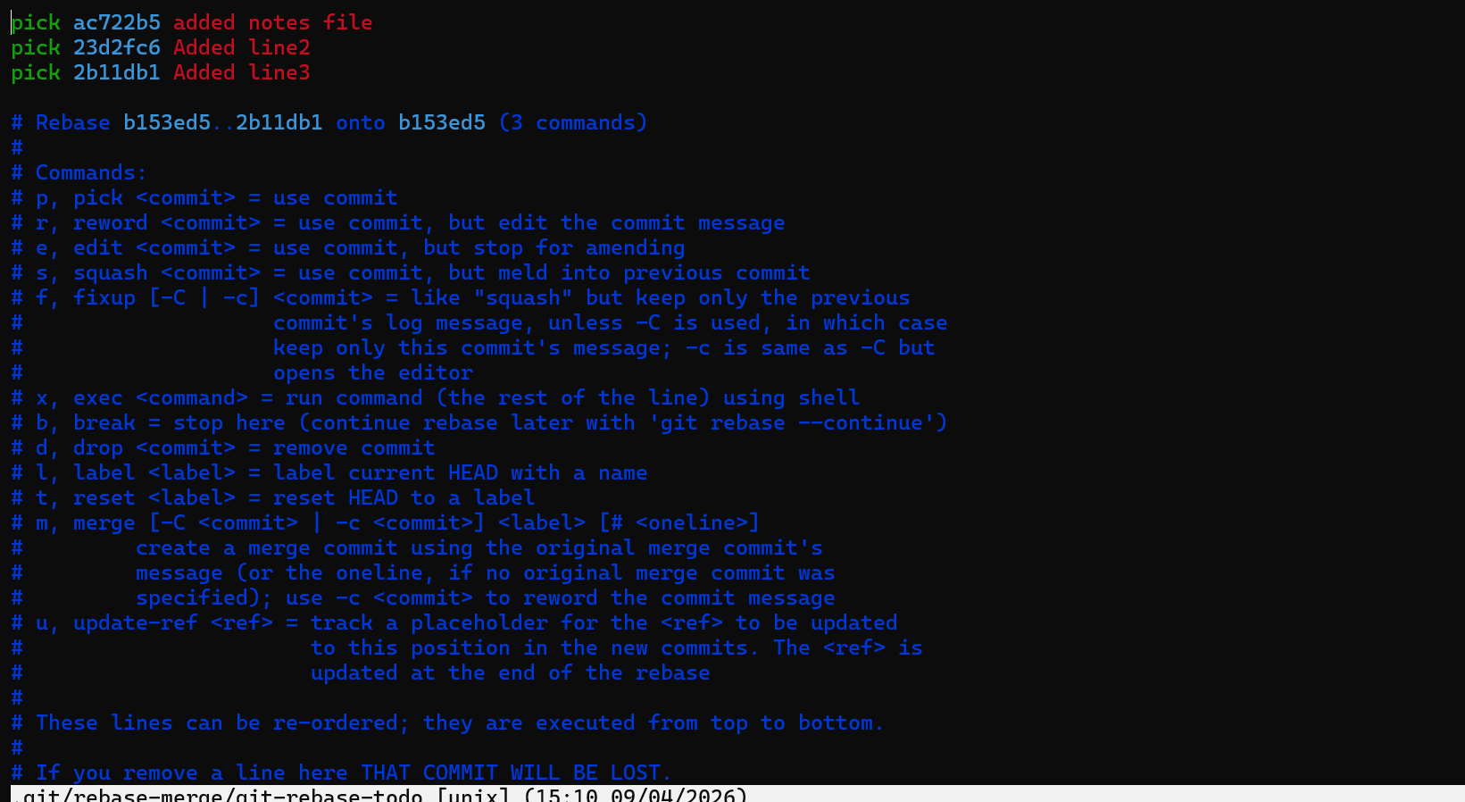
We will have this type of interface where we can pick or squash changes.
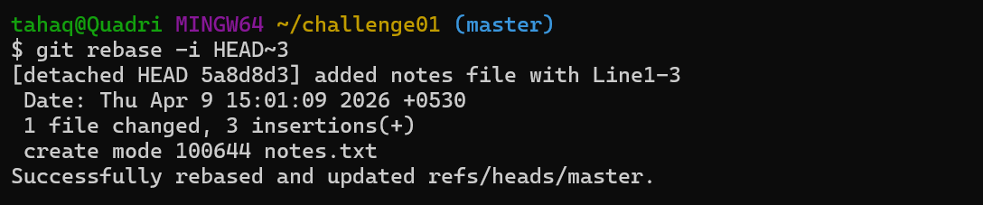
Instead of three commits, the branch history now shows one clean commit that contains all the changes.
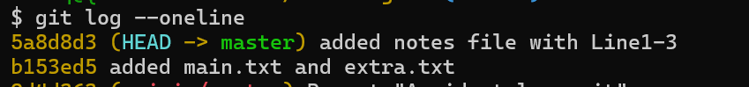

8.Tagging and Release:
Create a version tag(v1.0), push it to github, then delete and restore it.
Let’s create a tag and push it to github.
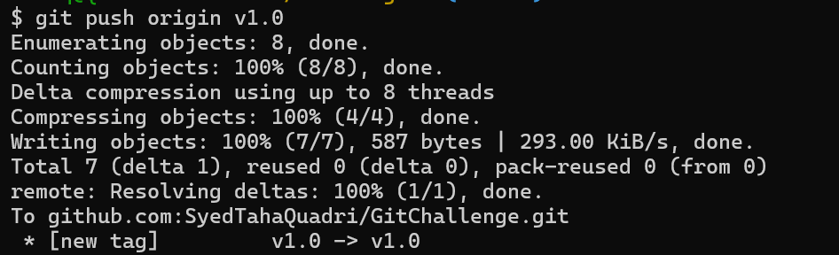
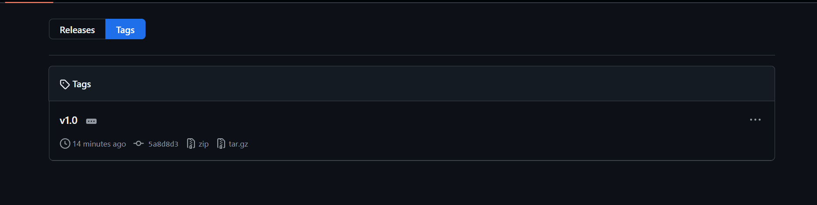
We have now added the tag and pushed it to github.
Now let’s delete the tag.
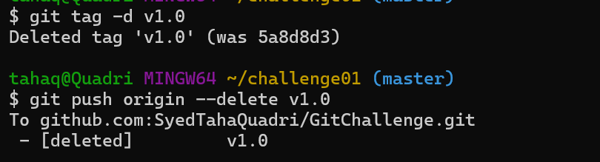
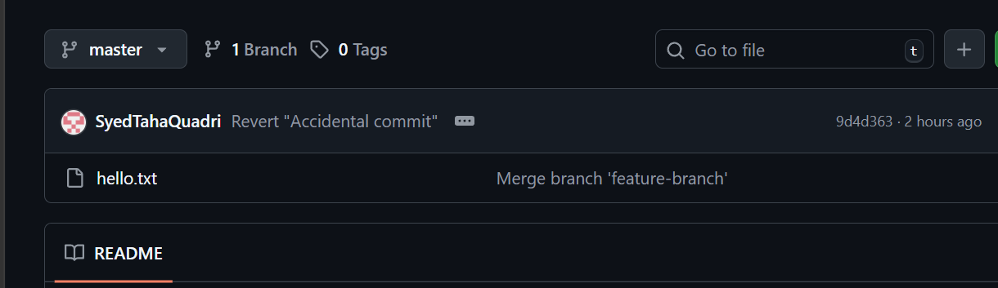
The tag has been deleted in the local repo as well in github.
now let’s again restore it.
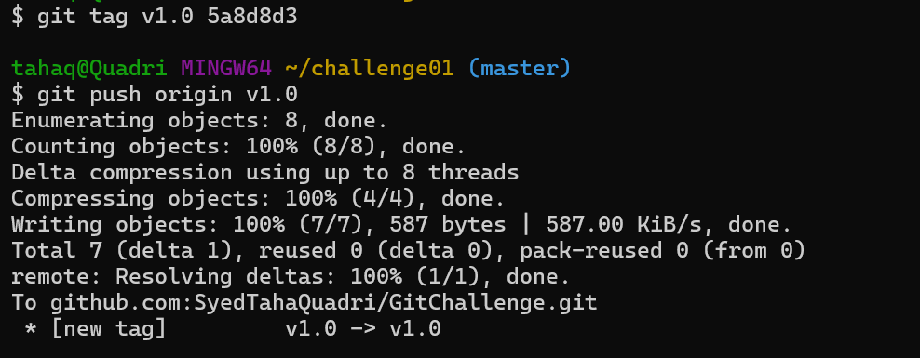
We have restored our tag.
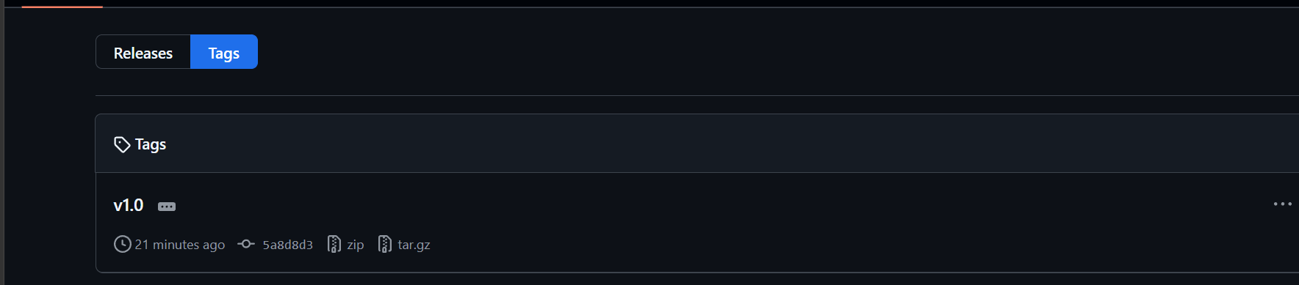

9.Clone with Sparse Checkout.
Let’s clone a repository in sparse mode.
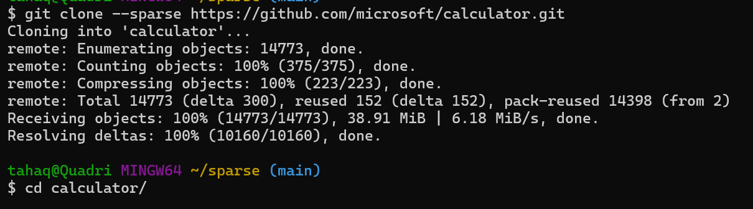

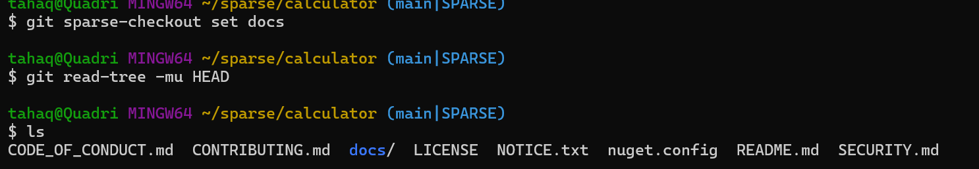
We only have docs folder from the calculator.git repository.
Instead of all the other folders which repo contains
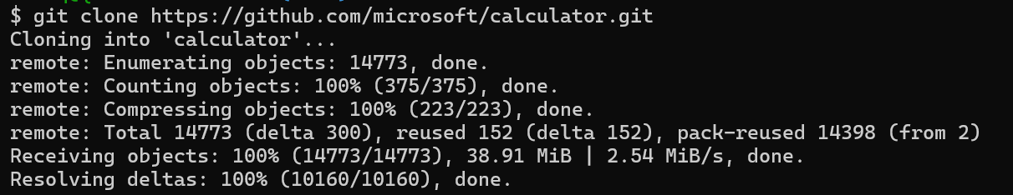
Confirming it by doing a normal clone
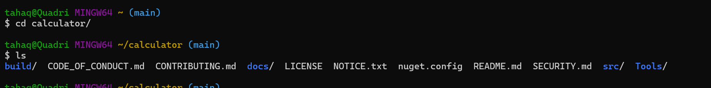

10.Reset vs Revert Challenge
Demonstrate the difference between git reset --hard and git revert in a repo.
First let’s create a new repository.
Now we have some commits in our repo
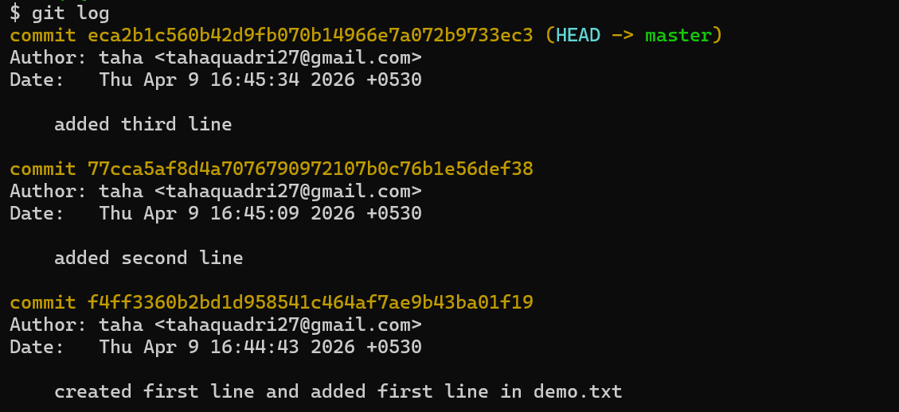
Now we have hard reset two commits which means that the two commits have been deleted.
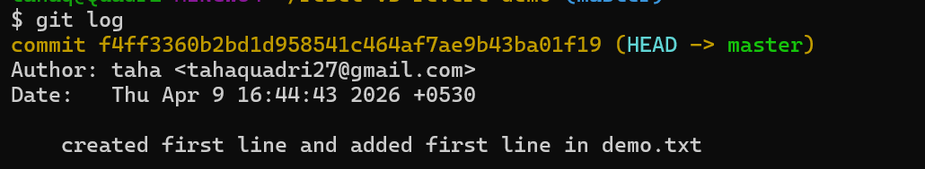
Now let’s get to revert.
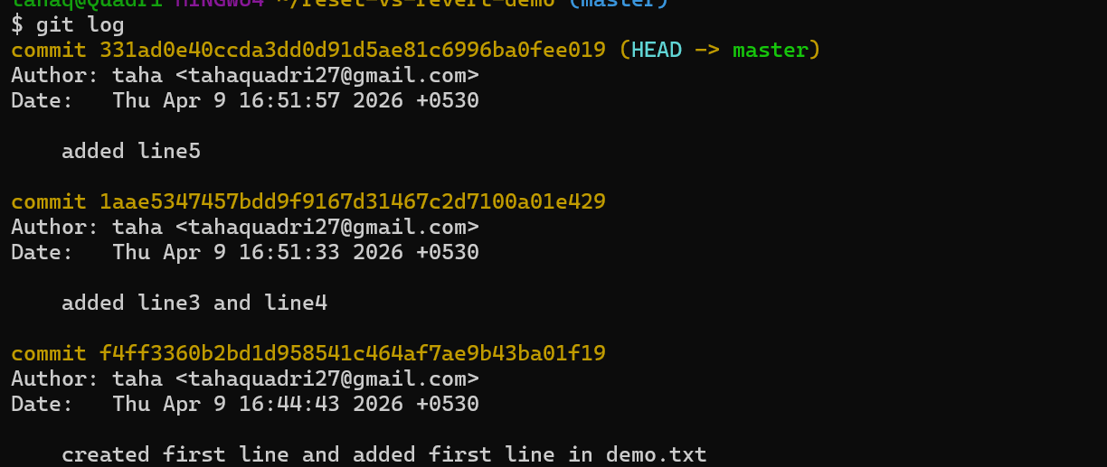
We have three commits now.
The file dep.txt looks like this now.
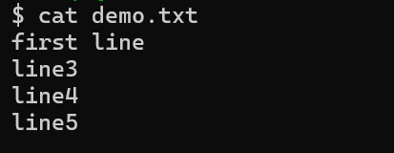


11.Checkout a specific commit (detached HEAD state) and create a new branch from it.
We have now checked out to commit
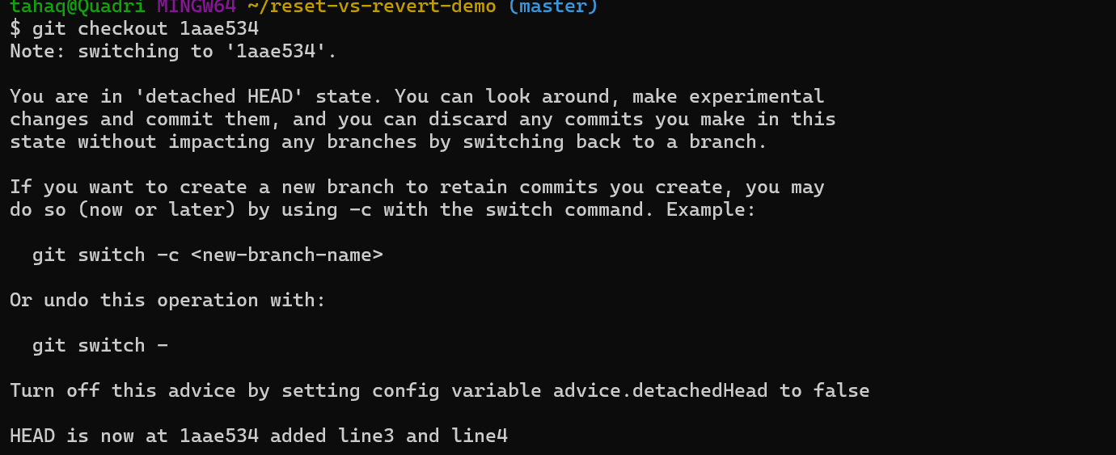
Head is not pointing to a commit not to a branch.

To save work starting from this commit, create a branch:
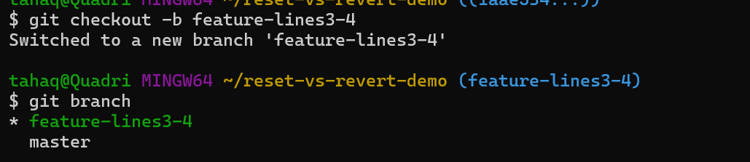
We have created a branch from the commit and work will be saved from the last commit only.
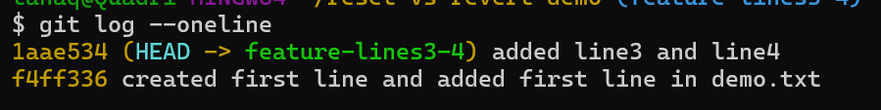

12.Configure a pre-commit hook to reject commits without a message format (e.g., must start with JIRA-XXX).
Let’s configure a pre-commit hook.
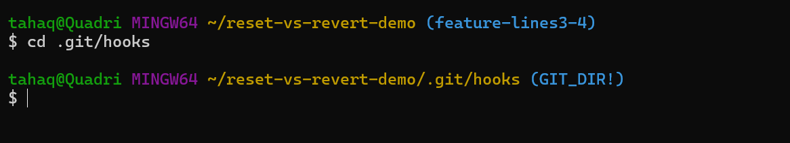
For that let’s create a new file commit-msg
Add the script that will configure pre commit message
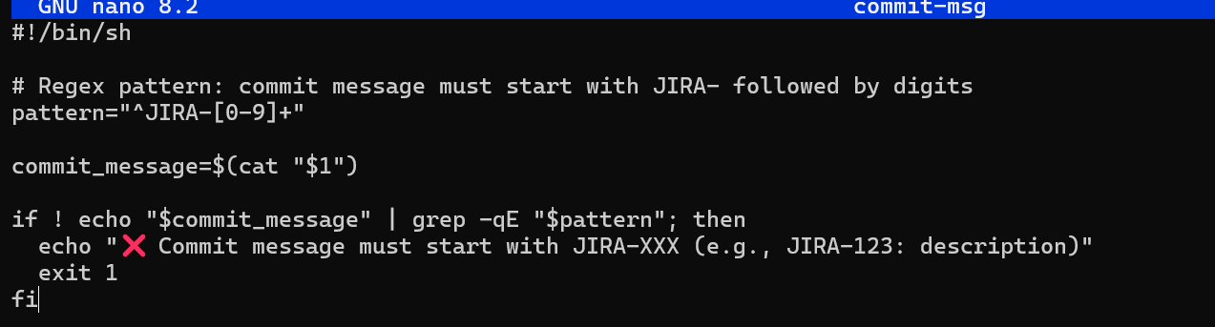
Let’s give the execute permission as well
Now let’s test it by committing.
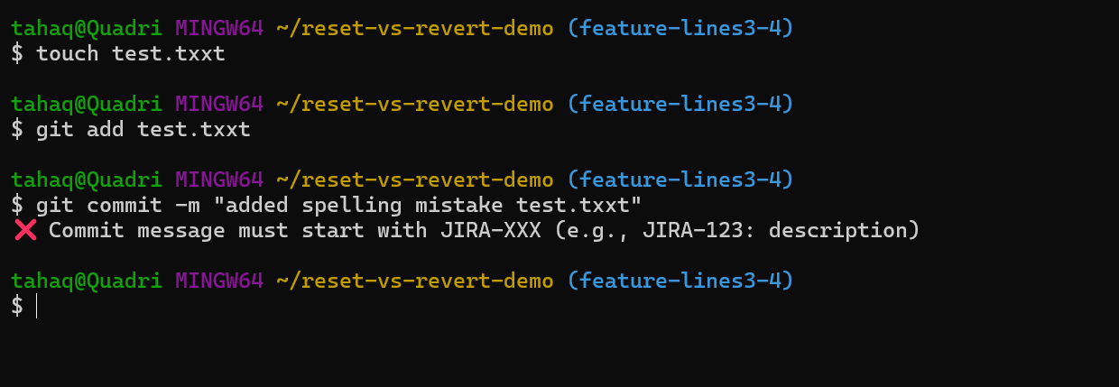
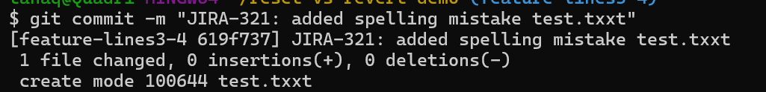

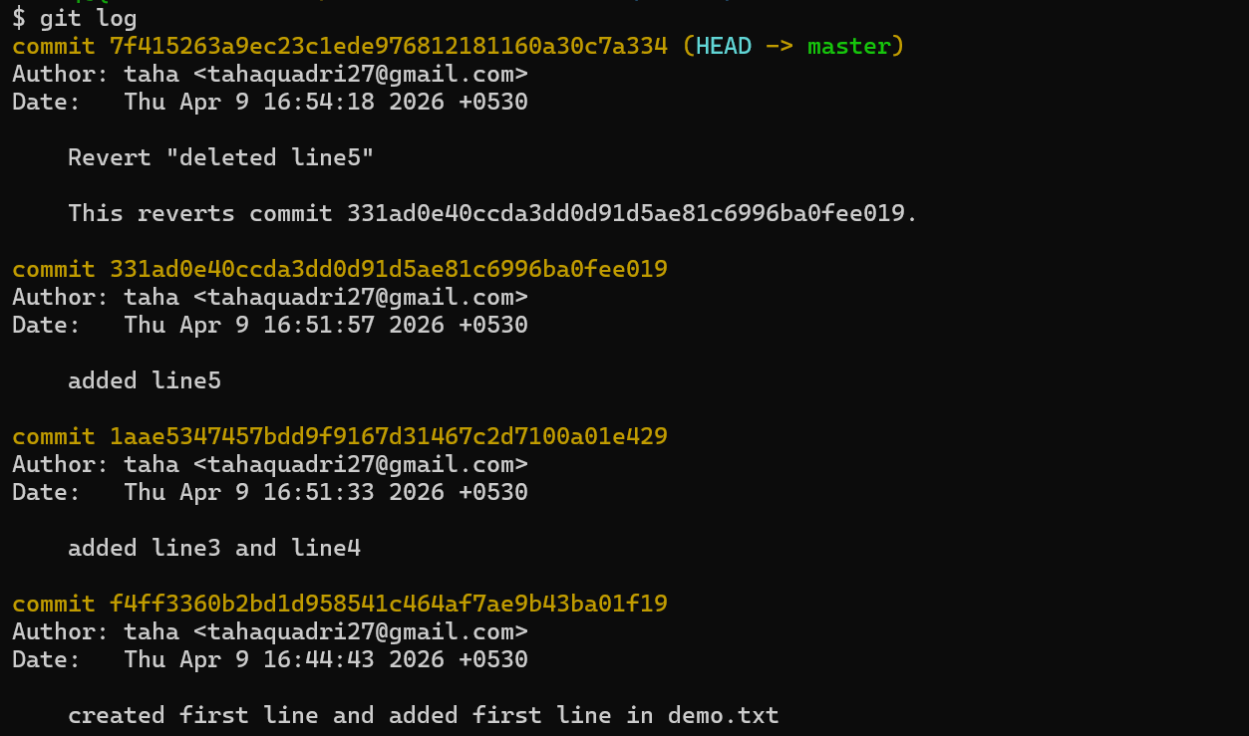
adds a new commit that cancels changes, history stays intact
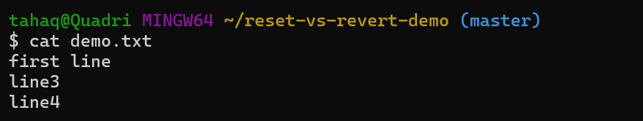

13.Squash Merge vs Rebase Merge.
Show the difference between squash merge and rebase merge with evidence
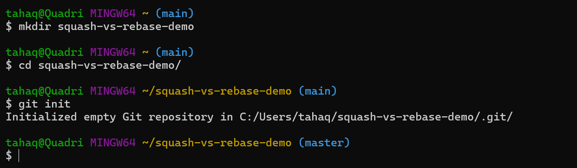
We have created a new directory and have initialized git in it.
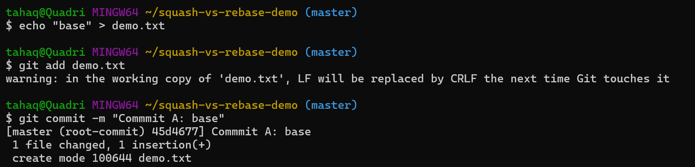
We have done the above changes in the master branch.
Now let’s create a new branch and do some changes there.
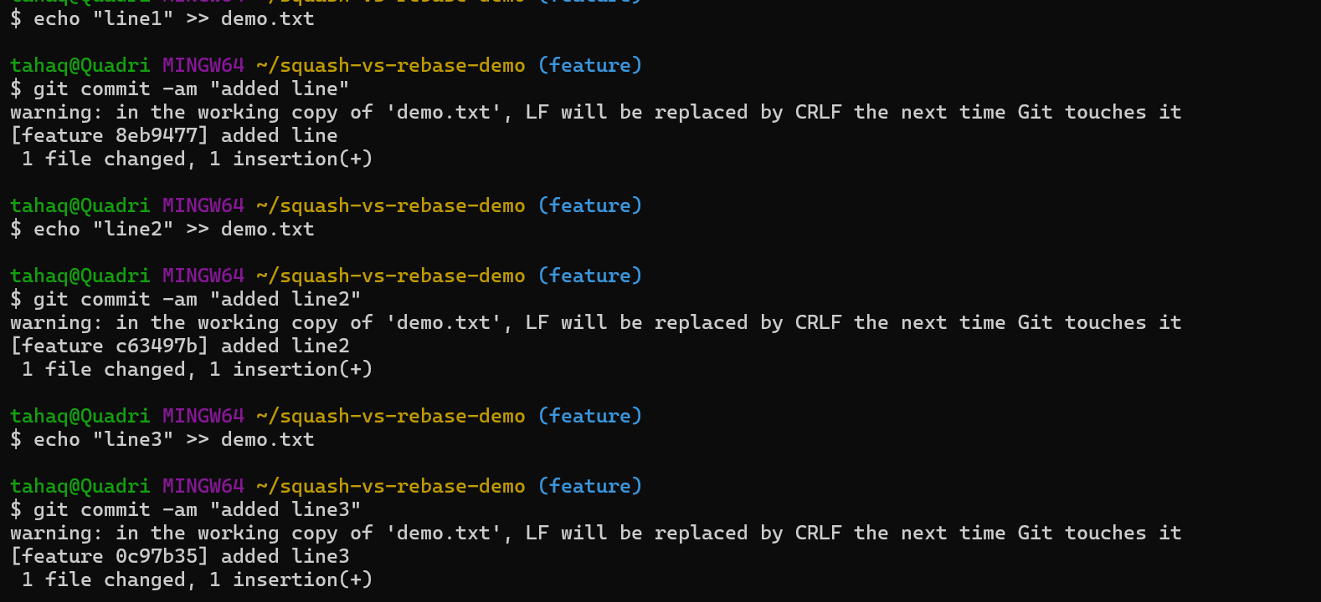

The history looks like this now
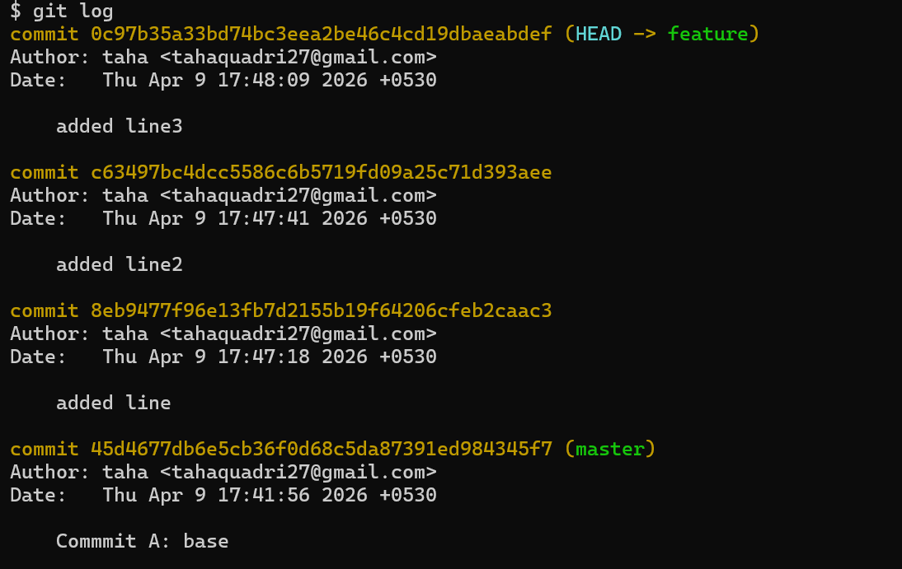

Now let’s checkout to master branch and merge the feature branch using the git merge command.
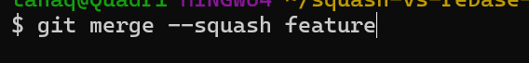

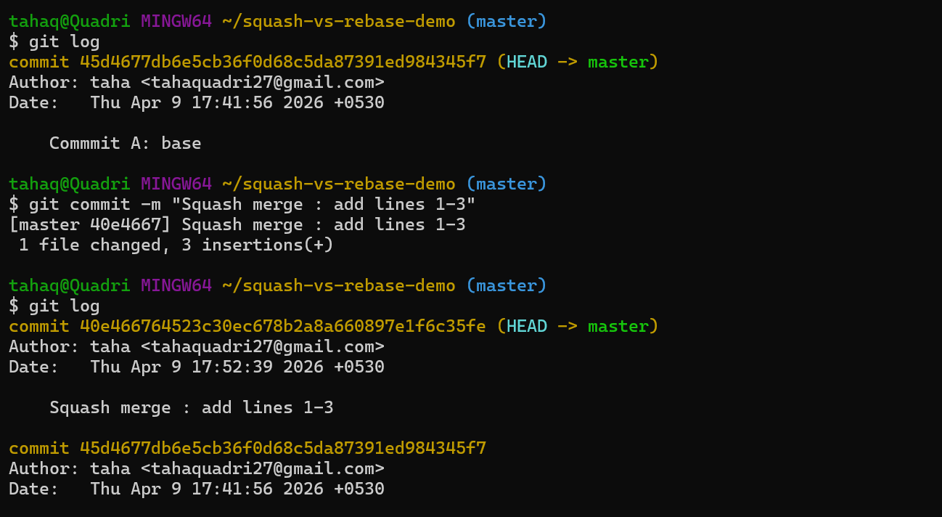
Now only new commit appear on main branch all the other commits were combined into one commit.

Now let’s do rebase merge.
Let’s create a new directory for it
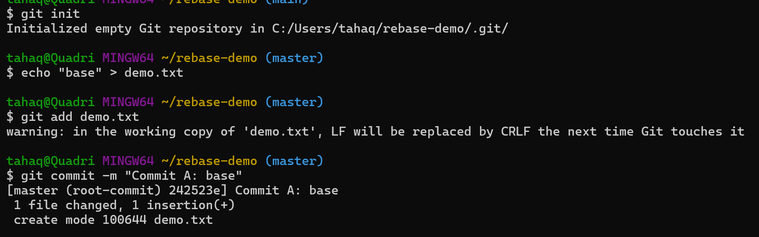
We have one file demo.txt and we have committed it as well.
We switched to the feature branch and have made some commits there.
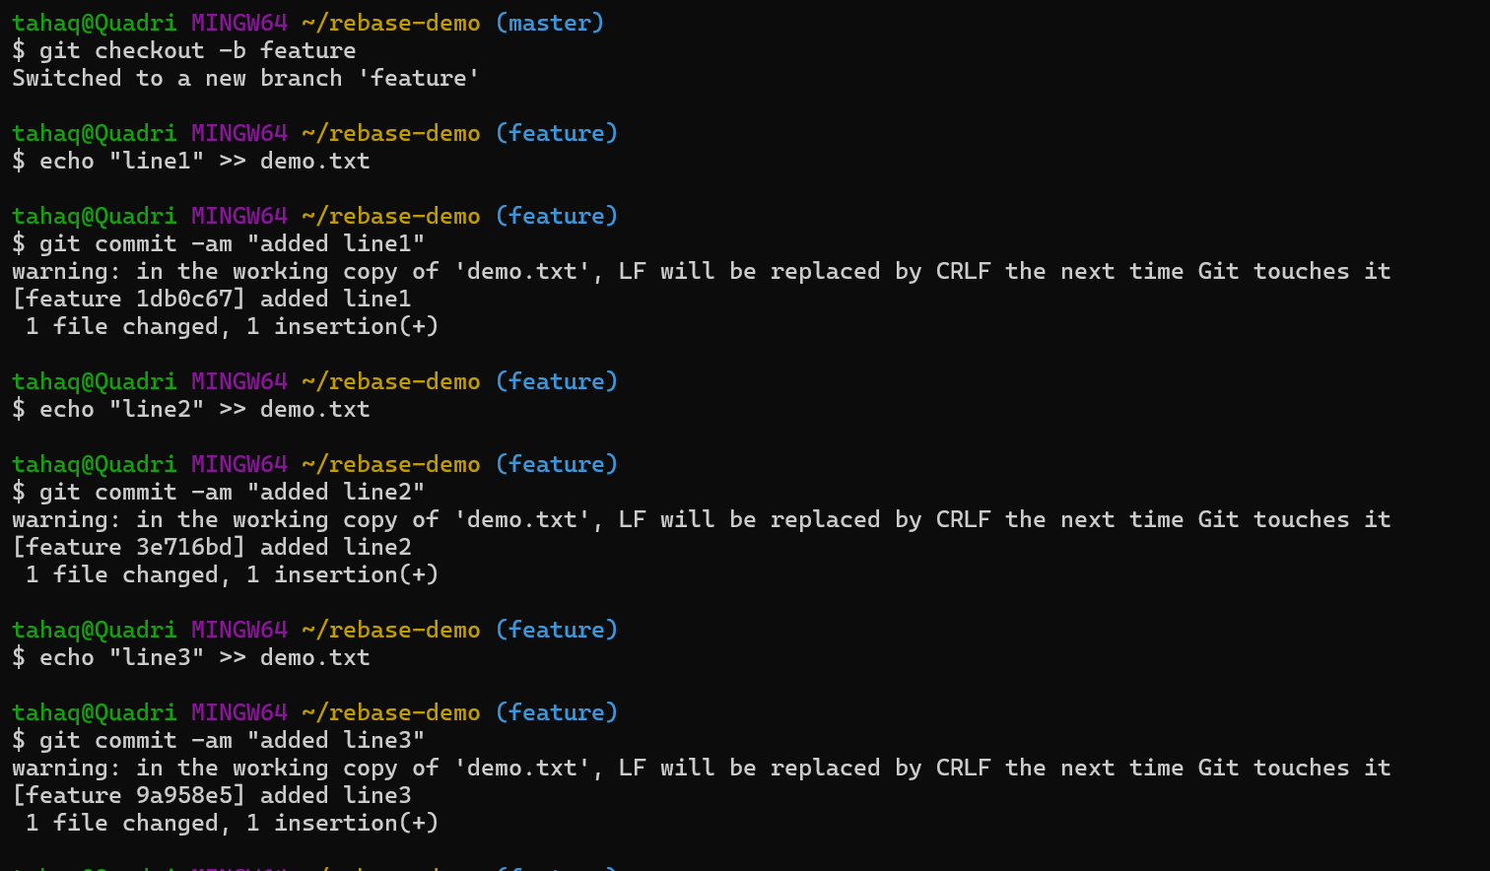
The history looks like this
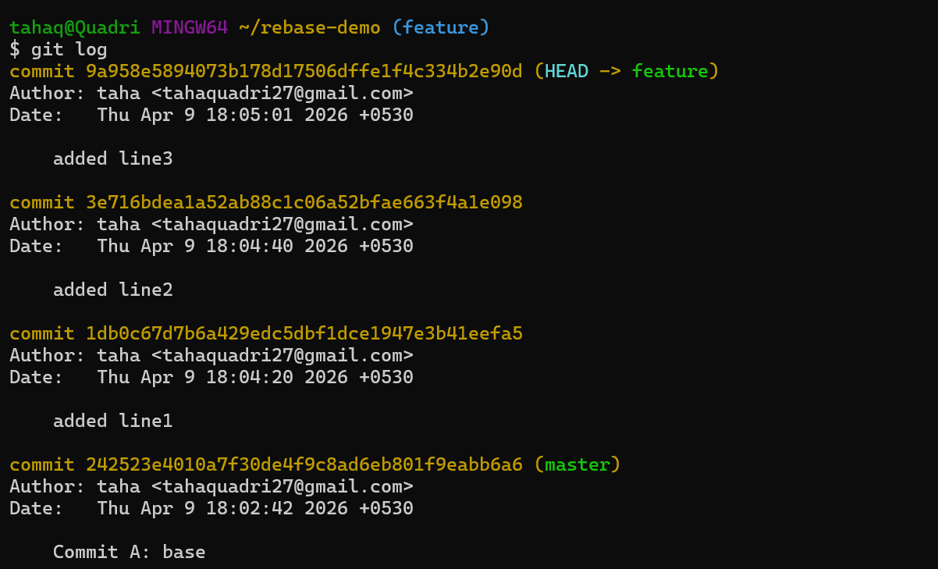

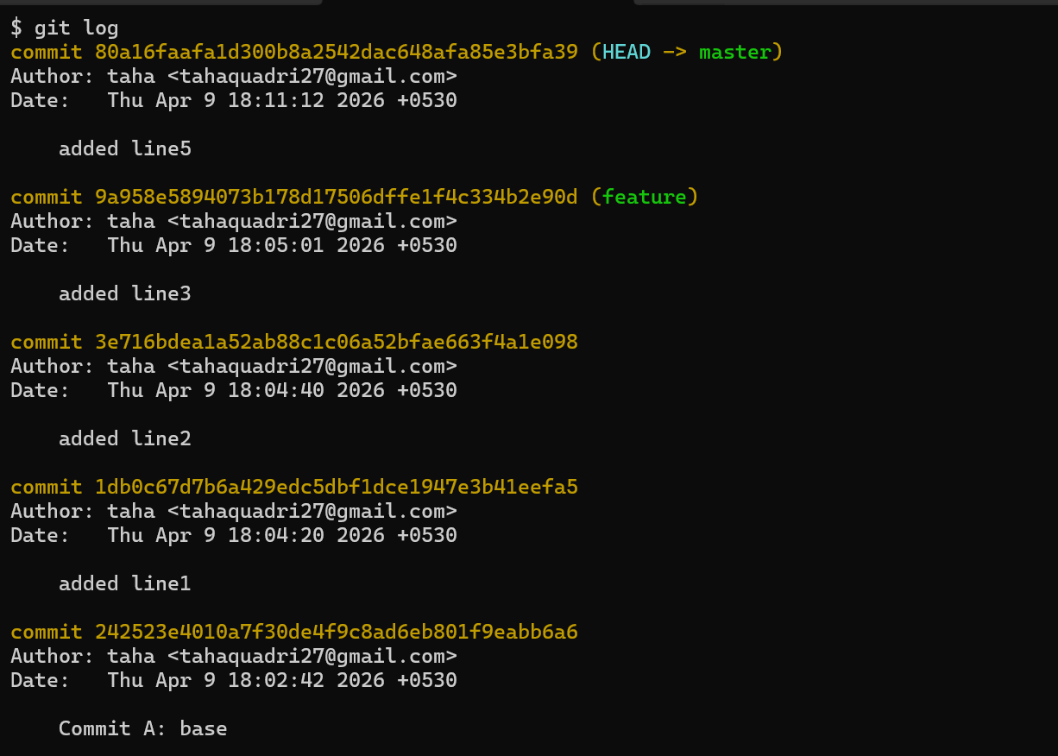
One more change we have made in master.
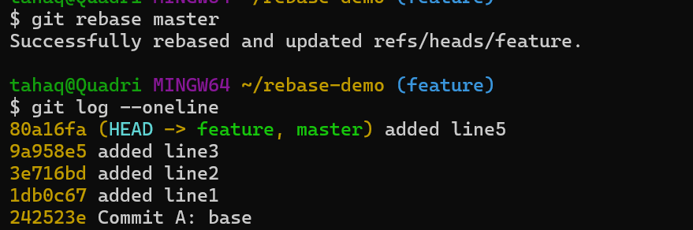

Here there is no extra merge commit which keeps the history clean.

14.Fork and Pull Request Workflow.
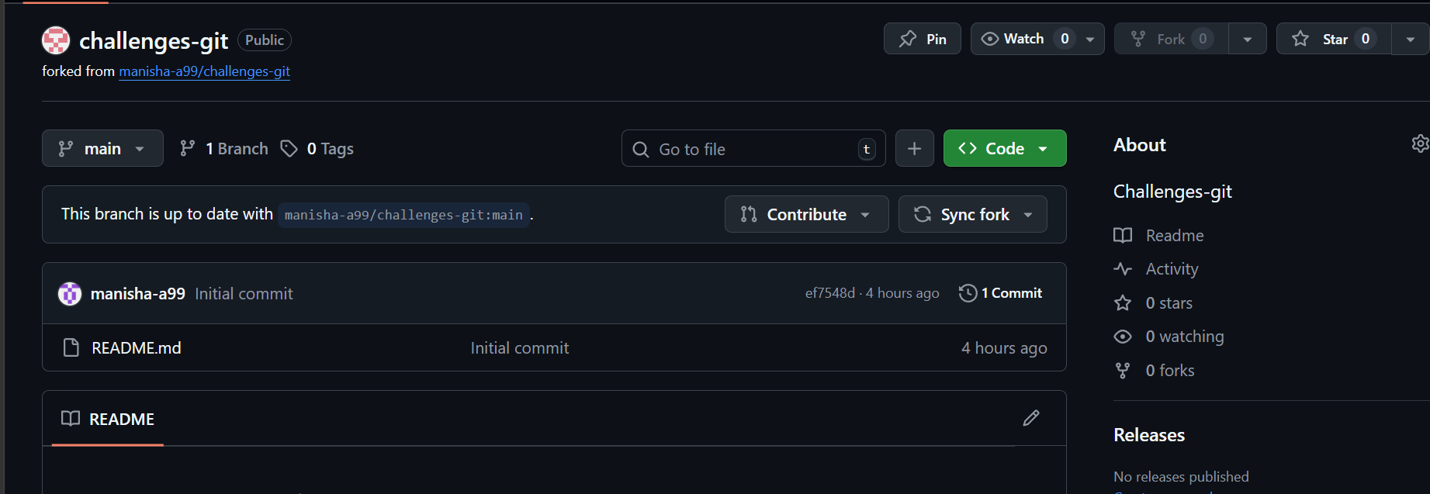
Here I have forked a repository from Manisha-a99’s github.
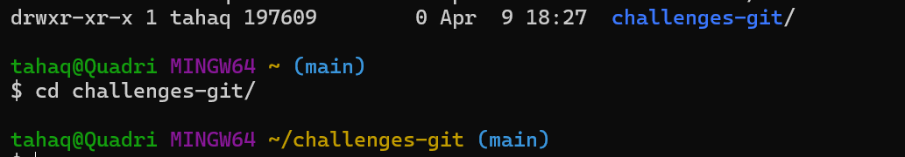
We have cloned in our local repository as well.
Added remote fork
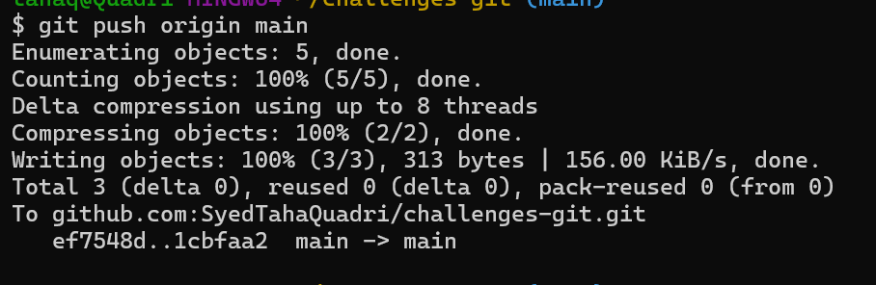
Pushed the changes as well
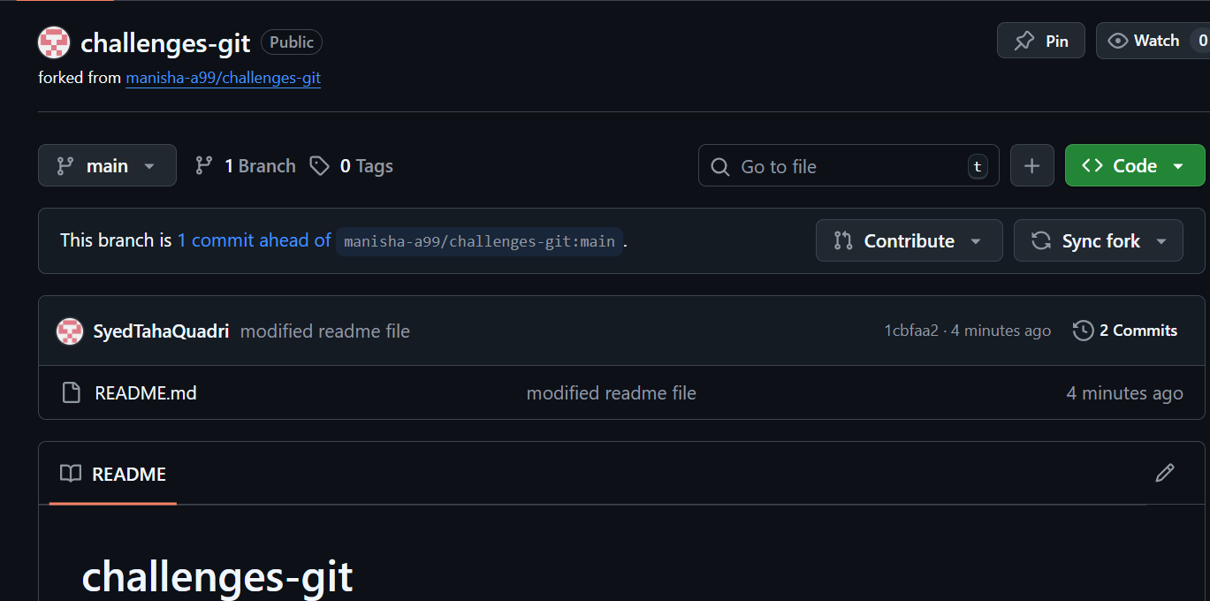

Creating a PR.
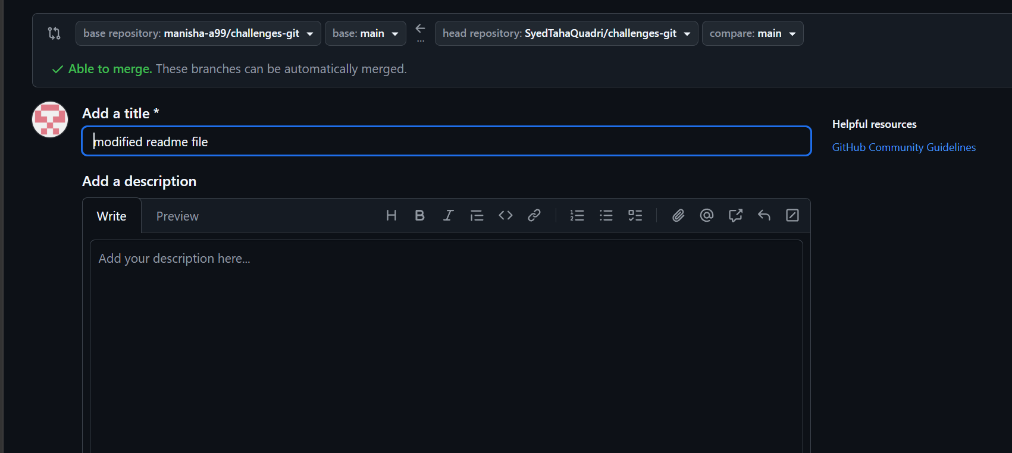

Submitted a pull request to original repo.
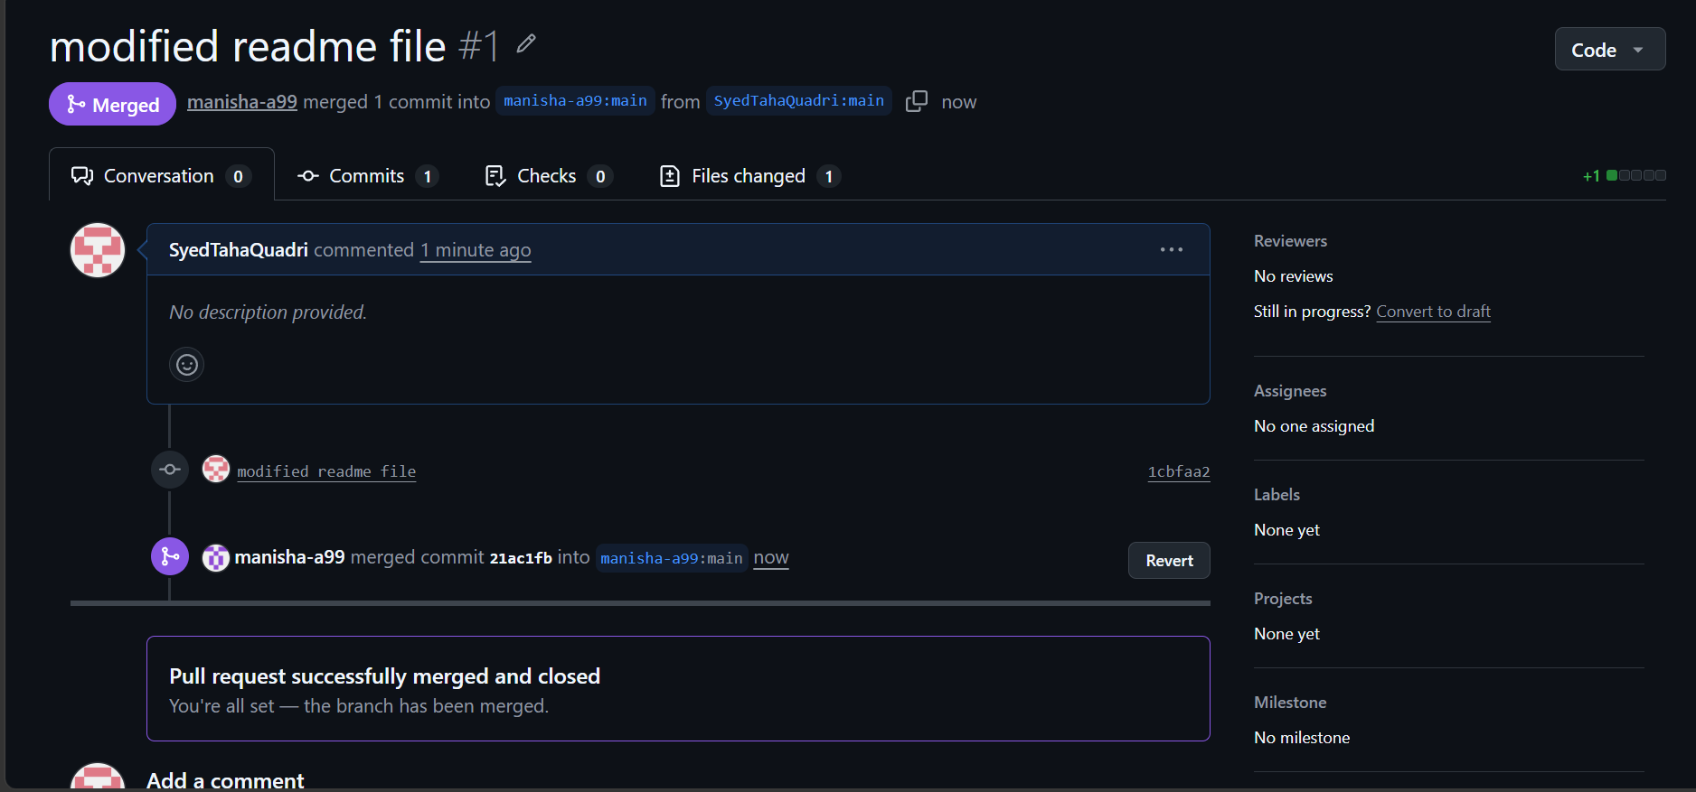

Changes applied to the original repository as well.
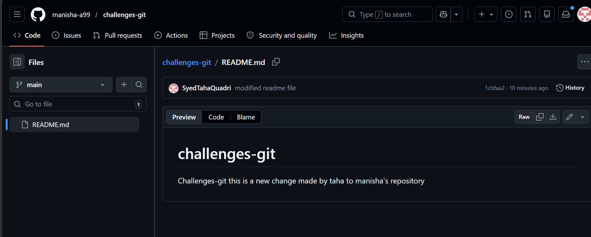

25.Recover lost commit:
Commit something, reset hard, and then recover it using git reflog.
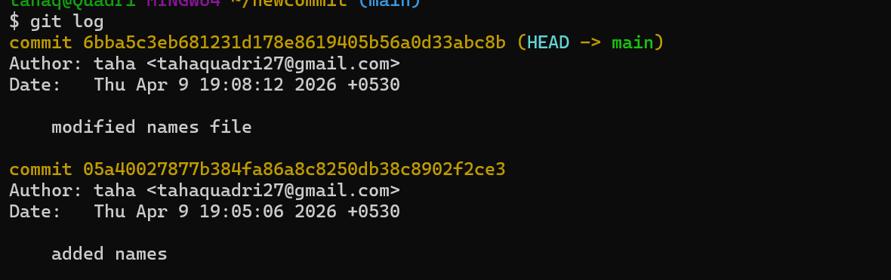
here we two commit
Suppose we made a commit by mistake and we don’t want it now.

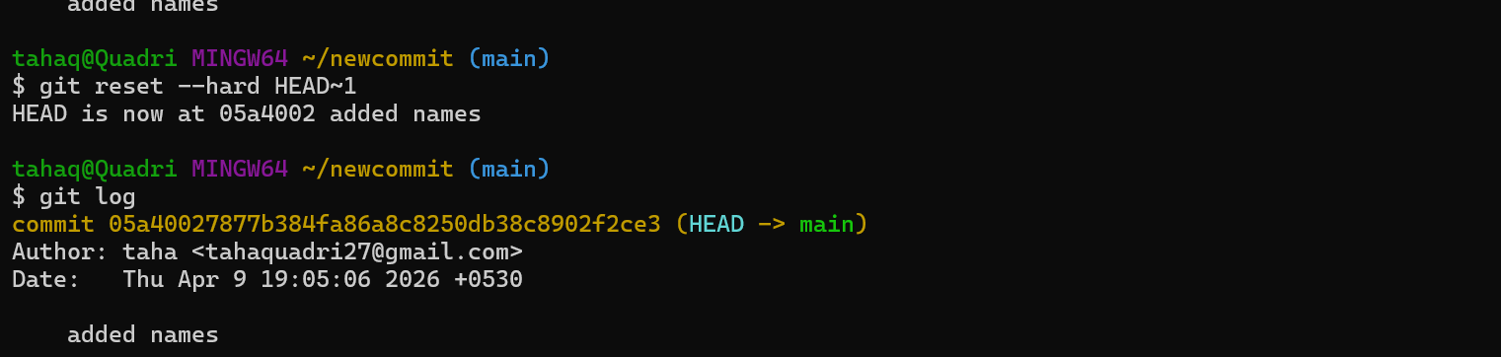
The commit which we made just now has been deleted by git reset head command.
Now let’s recover the file again.
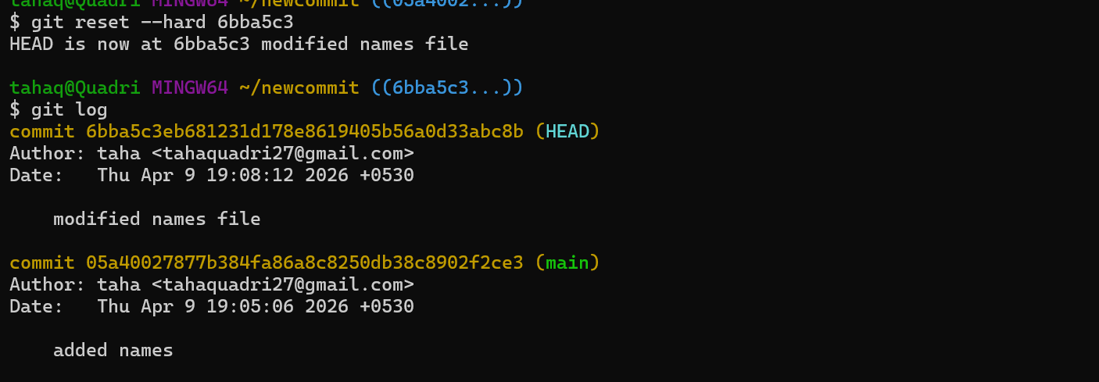
The commit has been restored now by using git reset and commit hash of that commit.

